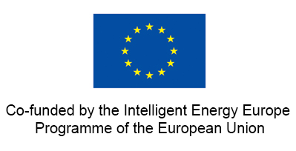

PRESS RELEASE
TOWARDS A EUROPEAN GEOTHERMAL RISK
INSURANCE FUND
21 June 2013

The GEOELEC project sets out a proposal for the establishment of a Geothermal Risk Insurance Fund at EU level

Geothermal energy is a renewable energy with many advantages; it is base load, local, flexible and environmentally friendly. Investors should be encouraged to take part in its promising development.

Despite this, its penetration into the energy market remains difficult. Although profits can easily be made, investors consider the geothermal resource as risky and are therefore reluctant to commit to projects.

Initial exploration yields important data regarding geothermal potential before drilling; however, a ‘geological risk’ still exists and can threaten the bankability of a project. The geological risk can be that adequate resources are not found (short term) or that the resource declines naturally over time (long term).

The geological risk is a common issue all over Europe, yet only certain countries (France, Germany, Iceland, The Netherlands and Switzerland) have insurance schemes.

The GEOELEC project calls for the establishment of a Geothermal Risk Insurance Fund at the EU level and, to this end, publishes today a report outlining such a scheme.

“Mitigating the risk associated with the geothermal resource and facilitating investments in geothermal electrical generation projects, this fund will not only reduce costs for countries which already have schemes in place but will also support the development of deep geothermal projects across Europe” said EGEC Secretary General Philippe Dumas.

This idea is not new but has been under discussion within the geothermal sector for about 15 years. For the first time, this report proposes how such a structure could be established and managed.

The report can be found on the GEOELEC website www.geoelec.eu

The GEOELEC project aims at promoting geothermal electricity generation in the EU and aims at removing notably financial barriers.

For further information contact:
Alexandra Latham
Communication officer, European Geothermal Energy Council
a.latham@egec.org / +32 2 400 10 27

The sole responsibility for the content of this publication etc.lies with the authors. It does not necessarily reflect the opinion of the European Union. Neither the EACI nor the European Commission are responsible for any use that may be made of the information contained therein.

